MED D – Late Enrollment Penalty (LEP) Attestation and Appeals

General Information – What is a Late Enrollment Penalty (LEP)?
Identifying an LEP in PeopleSafe
Review LEP Letters in OneClick
Verbal Attestations in RxEnroll Care
Reconsideration Requests (LEP Appeals)
Closing the Call
Resolution Time
Related Documents

Description: This document assists the CCR with MED D Late Enrollment Penalty (LEP) Attestations Appeals.

For Blue MedicareRx (NEJE), refer to MED D - Blue MedicareRx (NEJE) Late Enrollment Penalty (LEP).

General Information – What is a Late Enrollment Penalty (LEP)?
An LEP is assessed to those enrolling in a Part D plan who did not maintain creditable prescription drug coverage over a continuous period of sixty-three (63) days or longer where all of the following conditions were met:

The individual:
- Was eligible to enroll in a Part D plan.
- Was not covered under any creditable prescription drug coverage as showing in MARx.
- Was not enrolled in a Part D plan as showing in MARx.
- Was not incarcerated or living out of the country when they qualified for Part D.
- Is not eligible for Low Income Subsidy.

The beneficiary will:
- Be sent an Attestation Letter including a form (Declaration of Prior Prescription Drug Coverage) if the plan does not have a record of creditable coverage.
- Have 30 calendar days to respond from the time the letter is sent.
- If the form is returned, but it is incomplete, the plan will attempt to obtain the information with a phone call.
  - If all the information is not complete by the 30th day, a letter will be sent to the beneficiary advising that the LEP information has been submitted and an LEP will be assessed.
- The beneficiary is then given 60 days from the “reply by” date provided on the letter to dispute any potential LEP (total of 90 days from the original Attestation Letter date).
  - If the attestation information is received after the total 90 days, then it cannot be processed by the Plan and they will have to appeal directly with the Independent Review Entity, C2C Innovative Solutions. The Plan cannot assist the beneficiary in filing this appeal.

Notes:
- Low Income Subsidy eligible beneficiaries are not subject to a penalty.
- When the beneficiary is completing the attestation for other coverage the Plan does not require additional proof of coverage.
  - If the beneficiary, on their own initiative, provides proof of prior creditable prescription drug coverage, the plan sponsor will consider that information when determining whether the beneficiary had any gap in creditable coverage.

For more information, refer to: MED D - SilverScript Late Enrollment Penalty FAQ.
Top of the Document

Identifying an LEP in PeopleSafe

Perform the following:
Step | Action
1 | Is the caller the beneficiary, POA, Legal Representative or Ship Counselor?
1 | If the caller is… | Then…
1 | Beneficiary | Proceed to next step.
1 | Legal Representative | To review information for (Beneficiary’s Name), I need to verify that you are authorized to act on their behalf under the laws of the State in which the beneficiary resides. If asked to provide evidence of that authority to <SilverScript> or Medicare, would you be able to do so?
1 | Legal Representative | If… | Then…
1 | Legal Representative | Yes | Proceed to next step.
1 | Legal Representative | No | Determine if the Plan has POA information on file.  Refer to: MED D - Appointed Representative Form (AOR) or Power of Attorney (POA).  If the caller is not listed under POA/Authorized Rep Details, advise the caller to fill out the Declaration of Prior Prescription Drug Coverage form that was previously mailed to the beneficiary should be mailed to:  SilverScript  PO Box 30001  Pittsburgh, PA 15222-0330  Fax to: SilverScript Bizfax at 866-552-6205  CCR Process Note: The CCR must put detailed notes in PeopleSafe Med D Inquiry tab that the non-authorized party is aware of the verbal attestation process.  Proceed to Closing the Call.
1 | Ship Counselor | Refer to MED D - SHIP Counselor Calls for Part D Plans.  Proceed to next step.
2 | On the Main screen, click on the Medicare Part D Inquiry tab.  Note: The Medicare Part D Inquiry tab holds detail only for SilverScript.  - For clients which Caremark does not handle/process MED D enrollment refer to the client CIF for further direction.  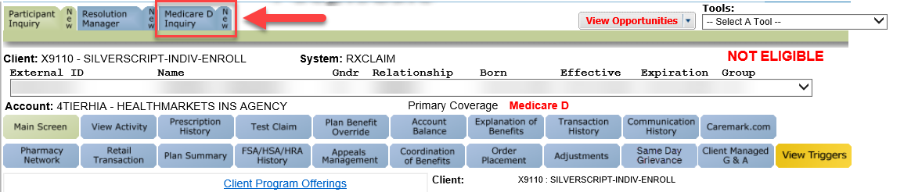  Proceed to the next step.
3 | Click on the Plan Details tab and review the Uncovered Months and Participant Penalty fields.  - Inform the beneficiary of the LEP amount being applied to their premium.  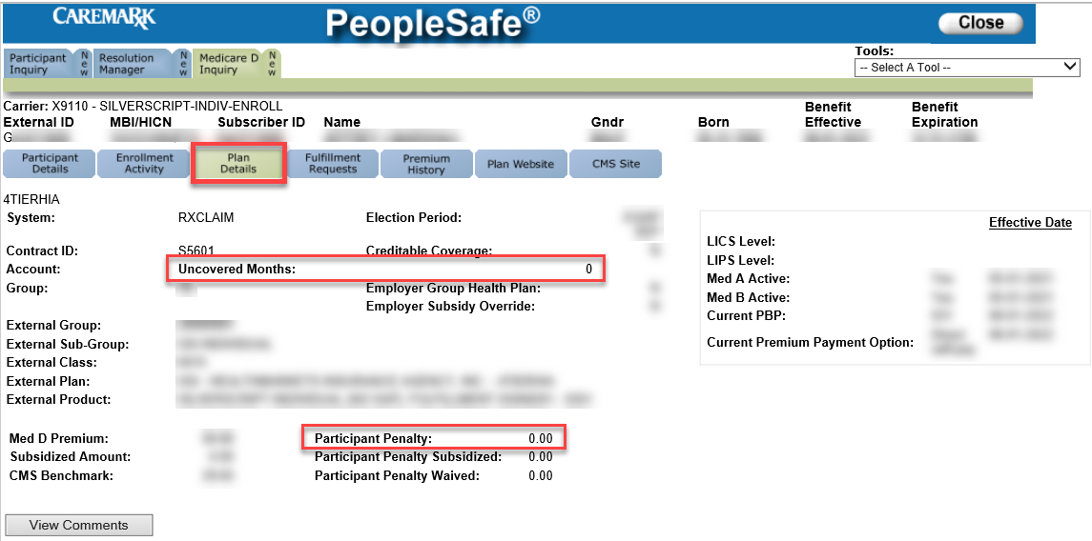  Proceed to the next step.
4 | Identify the reason the beneficiary (or third party) is calling.
4 | If… | Then…
4 | The caller needs to attest to coverage or questions their LEP. | Proceed to Verbal Attestations in RxEnroll Care.
4 | The caller references a letter regarding their LEP. | Proceed to Review LEP Letters in OneClick.
4 | The caller refers to a reconsideration request or needs a duplicate form. | Proceed to Reconsideration Requests (LEP Appeals)
4 | The caller has no further questions. | Proceed to Closing the Call.

Top of the Document

Review LEP Letters in OneClick

Perform the following:
Step | Action
1 | Review the LEP letter sent to the beneficiary (DLEP).  - Click on the Medicare D Inquiry Tab and click on the Last 12 months of Medicare Communication button to review the DLEPL letter.  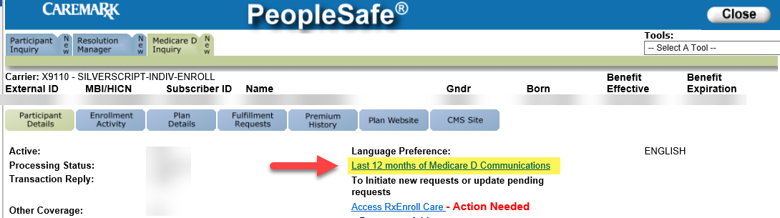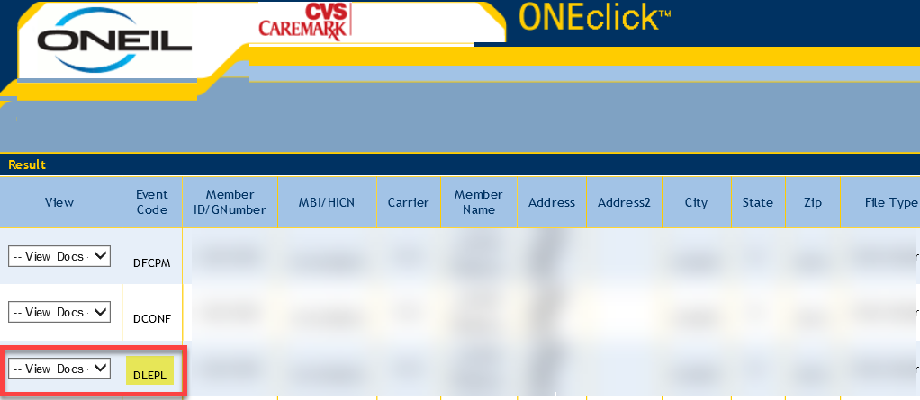  Verify if the beneficiary is contacting the plan within the 90 days from when the Attestation letter was sent.  - This is calculated by adding 60 days to the reply by date.  Example:  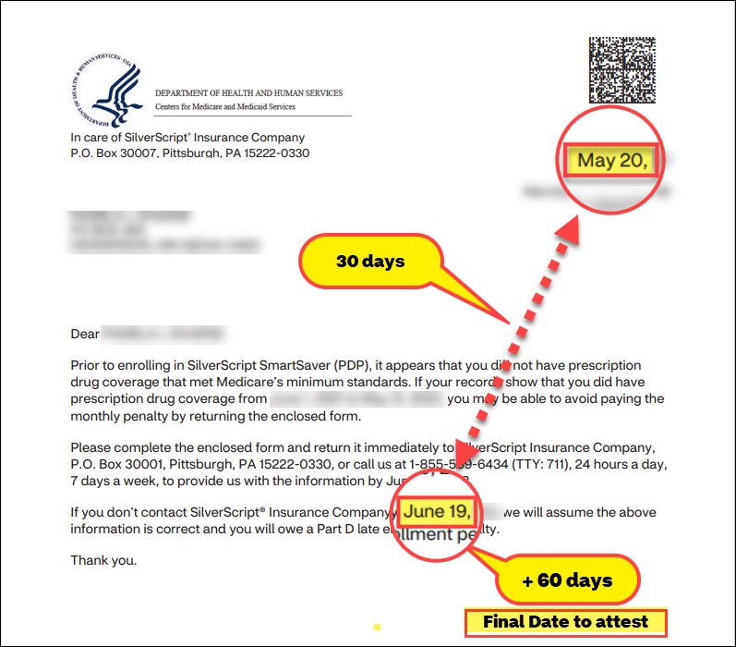
2 | If the caller… | Then…
2 | Needs to attest to coverage or questions their LEP. | Proceed to Verbal Attestations in RxEnroll Care.
2 | Has questions regarding a previous attestation or appeal. | Review Medicare D Inquiry Tab Comments for notes from the Member Services team that refer to the LEP.  Then, proceed to Reconsideration Requests (LEP Appeals).
2 | Has no further questions | Proceed to Closing the Call.

Top of the Document

Verbal Attestations in RxEnroll Care

Perform the following steps:
Step | Action
1 | Click the Access RxEnroll Care link located on the Participant Details screen of the Medicare D Inquiry tab in PeopleSafe.  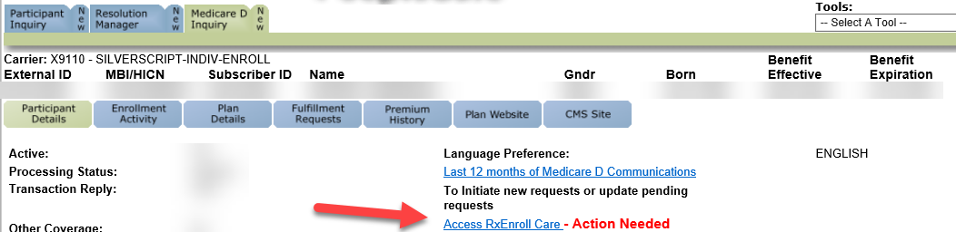  Notes:  - If there are additional tasks listed under Action Areas, reference the appropriate work instruction to resolve the task for the beneficiary before ending the call.  - If RxEnroll Care is unavailable proceed to MED D – Late Enrollment Penalty Attestations and Appeals (Downtime Procedures).
1 | If… | Then…
1 | The beneficiary has a pending LEP | Select LEP under Action Areas.  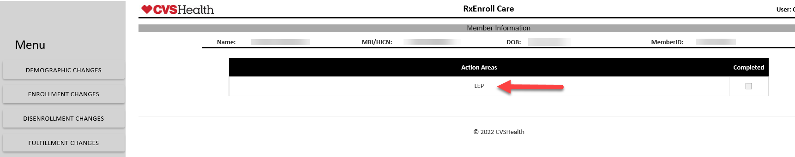  Proceed to next step.
1 | There is no LEP pending | Select ENROLLMENT CHANGES under the Menu on the left side of the screen and click on LEP Attestation.  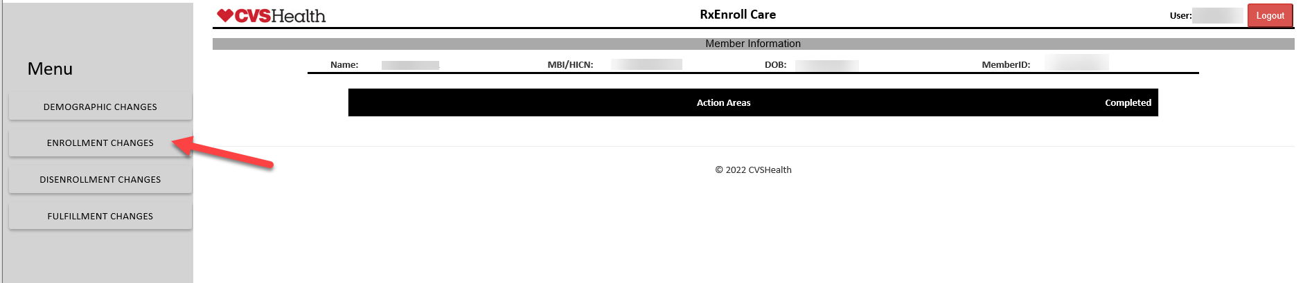  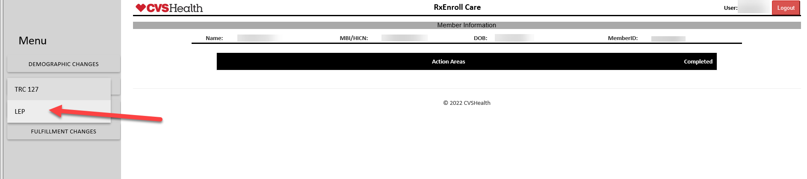  Proceed to next step.
2 | Review the message displayed under LEP Attestation to determine if the beneficiary is submitting a timely attestation. Then follow the prompts provided in the RxEnroll Care application.  Note: The default message on screen is, “Member has a pending LEP. Obtain a Verbal Attestation of Creditable Coverage.” However, the CCR should follow screen prompts to determine whether a verbal attestation can be taken or if it is past the 90-day window to attest.
2 | If beneficiary is… | Then…
2 | Contacting us within the 90-day window | And the person attesting is the... | Then...
2 | Contacting us within the 90-day window | Beneficiary | Proceed to next step.
2 | Contacting us within the 90-day window | Authorized Representative or Power of Attorney | Review the Authorized Rep field.    If the caller is someone other than the beneficiary or a POA listed under POA/Authorized Rep Details. The system will require the following information be collected from the caller: Name, Address, City, State, Zip, Phone and Relationship.  Note: You must check the Legal Rep Attestation box and read the Legal Rep Attestation message to the caller to confirm they are authorized to act on behalf of the beneficiary. The caller must attest to proceed with submitting the attestation.  If the legal representative does not have the appropriate information for verbal attestation, advise the caller to fill out the Declaration of Prior Prescription Drug Coverage form that was previously mailed to the beneficiary. Mail to:  SilverScript  PO Box 30001  Pittsburgh, PA 15222-0330  OR fax to: SilverScript Bizfax at 866-552-6205  Proceed to Step 4.
2 | Contacting us within the 90-day window | Ship Counselor | Refer to MED D - SHIP Counselor Calls for Part D Plans.  Proceed to next step.
2 | Contacting us within the 90-day window | Not permitted to attest | If the caller is not permitted to attest on behalf of the beneficiary for any reason, leave comments explaining the scenario and complete the task by clicking the Submit button.  Proceed to Closing the Call.
2 | Contacting us after the 90-day window  OR  Beneficiary is disputing the number of uncovered months and 90 days have passed since the Attestation Letter was sent  OR  The LEP was assessed by a prior plan | Proceed to Reconsideration Requests (LEP Appeals).  Note: The current text is not correct. Omit references to Medicare. The LEP information is sent to C2C Innovations for appeal.  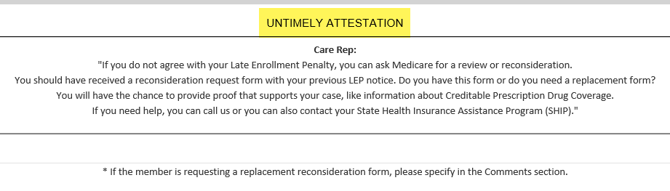
3 | Determine if the beneficiary had creditable prescription drug coverage for the LEP gap dates in question by reading the prompt under Coverage Confirmation.  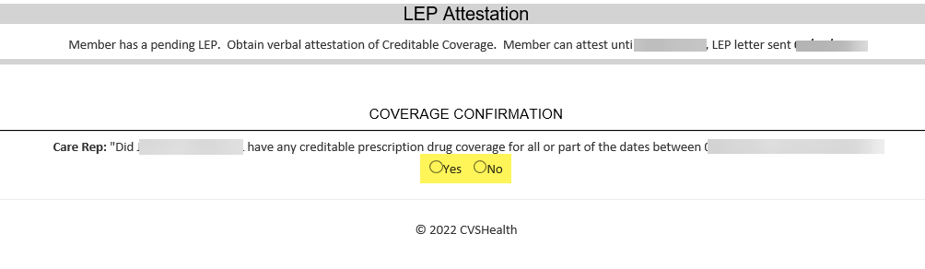
3 | If the caller answer is… | Then…
3 | Yes | Select Yes.  I can assist you with filling out the form you received by mail or you may submit your attestation verbally over the phone. Would you like me to complete a verbal attestation today?  Note: If the beneficiary was residing outside of the country/service area OR if the beneficiary was incarcerated during the dates in their letter, this time span should be entered as creditable prescription drug coverage with coverage type other. Clearly notate PeopleSafe and RxEnroll Care to indicate the beneficiary should not be assessed an LEP during a timeframe that they did not qualify for enrollment in a Part D plan.
3 | Yes | If... | Then...
3 | Yes | Yes | Proceed to next step.
3 | Yes | No | Enter the following comment in the pop-up box: “Beneficiary will mail in an attestation and declined to verbally attest.”  Advise the caller that the Declaration of Prior Prescription Drug Coverage form that was previously sent to the beneficiary should be mailed to:  SilverScript  PO Box 30001  Pittsburgh, PA 15222-0330  OR faxed to: SilverScript Bizfax at 866-552-6205  Click Submit.  Proceed to Closing the Call.
3 | No | Check No if the beneficiary does not have coverage for the dates shown under Coverage Confirmation.  - <Beneficiary’s name> do you attest that the information that you have provided is true and correct to the best of your knowledge?  - Therefore, do I have your authorization to submit your Attestation information for review?  - Thank you, <Beneficiary’s name> we at <SilverScript> will forward the information for review. Once we receive the decision, we (the plan) will send you a written notification regarding the decision. You will receive a letter to inform you of the final outcome.
3 | No | If... | Then...
3 | No | Yes | - Enter the following Comments in the pop-up box: “Beneficiary attests that all information provided is true and correct.”  - If needed provided Legal Rep or POA (Full name, address, phone number, and relationship to the beneficiary).  - Click Submit.  Proceed to Closing the Call.
3 | No | No | - The attestation cannot be submitted. The request can be stopped by clicking Cancel.  - Enter the following Comments in the pop-up box: “Beneficiary cannot attest that all information provided is true and correct.”  - If needed, provide Legal Rep or POA (Full name, address, phone number, and relationship to the beneficiary).  Proceed to Closing the Call.
4 | Follow the prompts provided on the screen to obtain the information being requested to complete the attestation:  Ask the beneficiary:  - What was the start date for your coverage?  - What was the end date for your coverage?  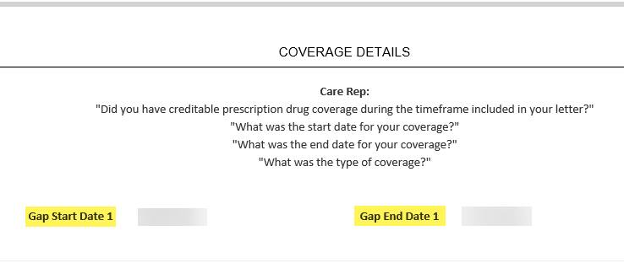  For each span of coverage being reported by the caller:  - Record the Creditable Coverage Start date using the calendar icon.  - Record the Creditable Coverage End date using the calendar icon.  - Choose the type of coverage from the drop-down menu  - To add additional spans of coverage, use the [+] icon to the right of the screen.  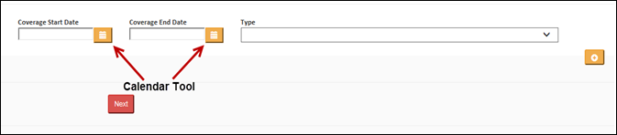  - Click the Calendar icon next to the date field.  - Select the year that coverage began/ended by clicking on the Month/Year at the top of the calendar.  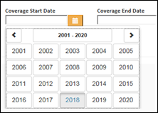  Note: Use the arrows to move the range of years.  - Select the month that coverage began/ended.  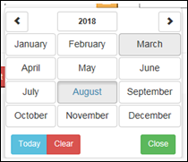  - Select the day of the month provided by the beneficiary. If the beneficiary only knows the month and year, select the 1st of the month.  Result: The date will populate in the date field.  If the beneficiary is attesting that their coverage started in a year prior to the gap dates shown on the Coverage Details Screen, it is acceptable to use the start month/year of the Gap Start Date (shown below) as the Coverage Start Date.    When all spans of creditable coverage are entered, click on Next to proceed to the Confirm Attestation Screen.  Proceed to next step.
5 | - (Beneficiary Name) do you attest that the information that you have provided is true and correct to the best of your knowledge?  - Therefore, do I have your authorization to submit your Attestation information for review?  - Thank you, (Beneficiary’s Name), we at <SilverScript> will forward the information for review. Once we receive the decision, we (the plan) will send you a written notification regarding the decision. You will receive a letter informing you of the outcome.  If caller agrees with the disclaimer: Select Yes.  If caller does not agree with the disclaimer: Select No.  Copy comments to use in Closing the Call for Participant Inquiry Tab.  If the legal representative does not have the appropriate information for verbal attestation, advise the caller to fill out the Declaration of Prior Prescription Drug Coverage form that was previously mailed to the beneficiary.  SilverScript  PO Box 30001  Pittsburgh, PA 15222-0330  Fax to: SilverScript Bizfax at 866-552-6205  Proceed to the next step.
6 | Proceed to Closing the Call.

Top of the Document

Reconsideration Requests (LEP Appeals)

Reconsideration requests (Appeals) for a Late Enrollment Penalty are not handled directly by the Plan. It is the responsibility of the beneficiary or the beneficiary’s POA to complete a Reconsideration packet and mail or fax the forms to the Independent Review Entity (IRE).

The current IRE is C2C Innovative Solutions. For more information on the appeals process and to obtain a Reconsideration request Form, the beneficiary can visit:

https://partdappeals.c2cinc.com// - Click on Part D Enrollees & Representatives and then Forms.

The beneficiary may also visit the following website to obtain the form, but the form must be filed with C2C Innovative Solutions:

https://www.cms.gov/Medicare/Appeals-and-Grievances/MedPrescriptDrugApplGriev/Late-Enrollment-Penalty-LEP-Appeals

Do NOT under any circumstances refer the beneficiary or a third party to Medicare.

Step | Action
1 | - If you do not agree with your Late Enrollment Penalty, you can ask for a reconsideration by submitting a Part D Late Enrollment Penalty Reconsideration Request Form.  - You will have the chance to provide proof that supports your case, like information about Creditable Prescription Drug Coverage.  - If you need help completing the form you can contact your State Health Insurance Assistance Program (SHIP).  Note: Once a decision is made, each Part D plan that the beneficiary had ever been enrolled in, will be notified of the decision.  Proceed to the next step.
2 | You should have received a reconsideration request form with your previous LEP notice. Do you have this form, or do you need a replacement form?  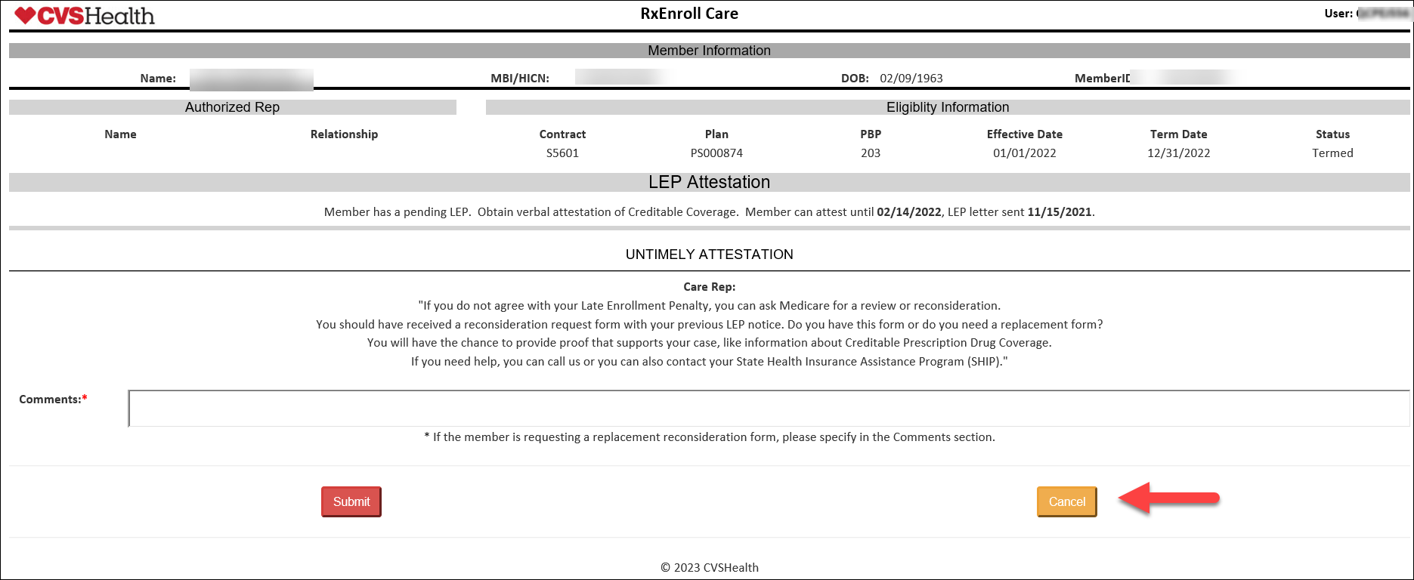
2 | If… | Then…
2 | Yes | Click on the Cancel button and follow the prompts to return to the main screen and exit out of the RxEnroll Care tool.  Proceed to the next step.
2 | No | Proceed to Closing the Call.
3 | From the Medicare D Inquiry Tab page, navigate to the Fulfillment Requests section.  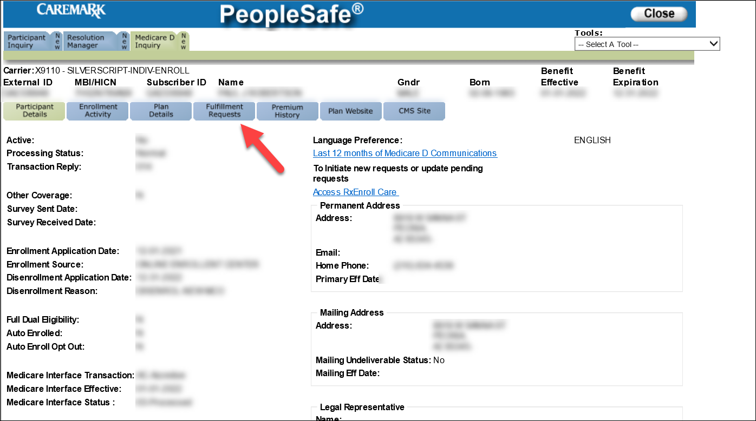
4 | Select LEP IRE Reconsideration from the Fulfillment List and click the Add button. Then, confirm the beneficiary’s address is correct and click on the Save Order button to send the form to the address listed.  Note: If the address is incorrect or the beneficiary requests a different address, click the Change Address button to change the address in the PeopleSafe Inquiry Tab.  Any changes must also be completed in RxEnroll Care and the Participant Inquiry section of PeopleSafe. Refer to Med D – Address Changes and Out of Area.  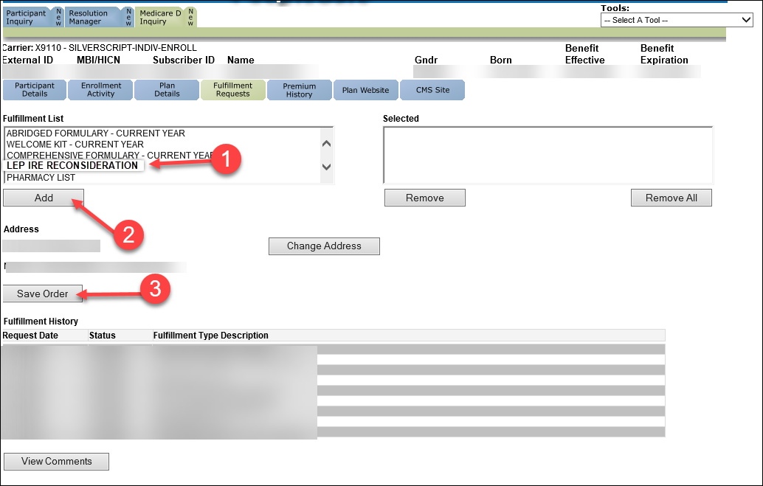
5 | You should receive the form within 7-10 business days.  Proceed to Closing the Call.

Top of the Document

Closing the Call

Perform the following:
Step | Action
1 | From the Participant Inquiry tab click on the Capture Activity button on the bottom left of the screen.
2 | In the Log Activity Notes field, use the RxEnroll or RM task notes to document the call.
3 | Click on Save Changes.
4 | - Thank you for your time today.  - As a quality measure, have I fully answered and resolved <your/the beneficiary’s> question(s) to <your/the beneficiary’s> satisfaction?
4 | If… | Then…
4 | Yes | Close the call:  - Address any benefit issues.  - Document and close the call according to existing policies and procedures, including all options discussed.  Note: Refer to the MED D - Call Documentation Including Viewing and Adding Comments in PeopleSafe Work Instruction.
4 | No | - Ask additional probing questions to attempt to resolve remaining questions or concerns.  - If unable to resolve the questions/concerns, transfer the call to a Senior Team.
5 | If needed, transfer the beneficiary to the appropriate department. (Licensed Enrollment Agent, Premium Billing, Senior Team, etc.)

Top of the Document

Resolution Time

- For Attestations: Up to 30 days depending on the information provided.

- For Appeals through C2C: Up to 90 days to receive resolution information from C2C Innovations.

Top of the Document

Related Documents

- Grievance Standard Verbiage (for use in Discussion with Beneficiary) section in MED D - Grievances Index
- Log Activity/Capture Activity Codes

Parent SOP: CALL-0048: Medicare Part D Customer Care Call Center Requirements-CVS Caremark Part D Services, L.L.C.
Abbreviations/Definitions: Abbreviations / Definitions

Top of the Document

Not to Be Reproduced or Disclosed to Others without Prior Written Approval
ELECTRONIC DATA = OFFICIAL VERSION - PAPER COPY = INFORMATIONAL ONLY

